1. About FitNoQuit
2. Getting Started with FitNoQuit
   1. Sign Up
   2. Log in
3. Get personalized results by entering your details in Profile Page
4. Diet
   1. Generate a new diet
   2. View existing diet and regenerating meals from the diet
5. Workout
   1. Generate a new workout
   2. View existing workout plan
6. Track your Progress
   1. Update weight and other metrics that have changed to keep your progress in check
7. Expanding knowledge about new diets, health and fitness trends
   1. Blogs
8. In today’s fast-paced world, it is not uncommon for people to experience mental and physical illness. Various scientific studies have shown that a wholesome diet and any form of physical activity helps in relieving health issues and progress towards a healthy lifestyle both physically and mentally. However, not everyone has the appropriate knowledge to help them reach their fitness goal. Thus, we present a one-stop solution to all these problems and present our intelligent web application named “FitNoQuit”, that is developed using Machine Learning. FitNoQuit takes into account various parameters like your height, weight, age and then calculates your current BMI & BMR. It also considers your food preferences like vegetarian/Non-vegetarian/Vegan, and chronic health conditions like diabetes, PCOS, thyroid, etc. These details enable our algorithm to formulate a plan that is accurate and easy to follow for you. FNQ also provides you with a workout plan which would complement your diet and accelerate your fitness journey. You can further browse through the blog section where a plethora of information concerning current diet and workout trends, myths regarding health and so on is available.
9. FNQ’s user interface has been designed to serve you the best and enhance your user experience by keeping the application simple to use and at the same time satisfying all your needs.
   1. To Sign Up to FNQ, you need to enter your first name, last name, email Id, user name, and password.

Password Should have:

* + - At least one number.
    - Should have at least one uppercase and one lowercase character.
    - Should have at least one special symbol.
    - Should be between 6 to 20 characters long

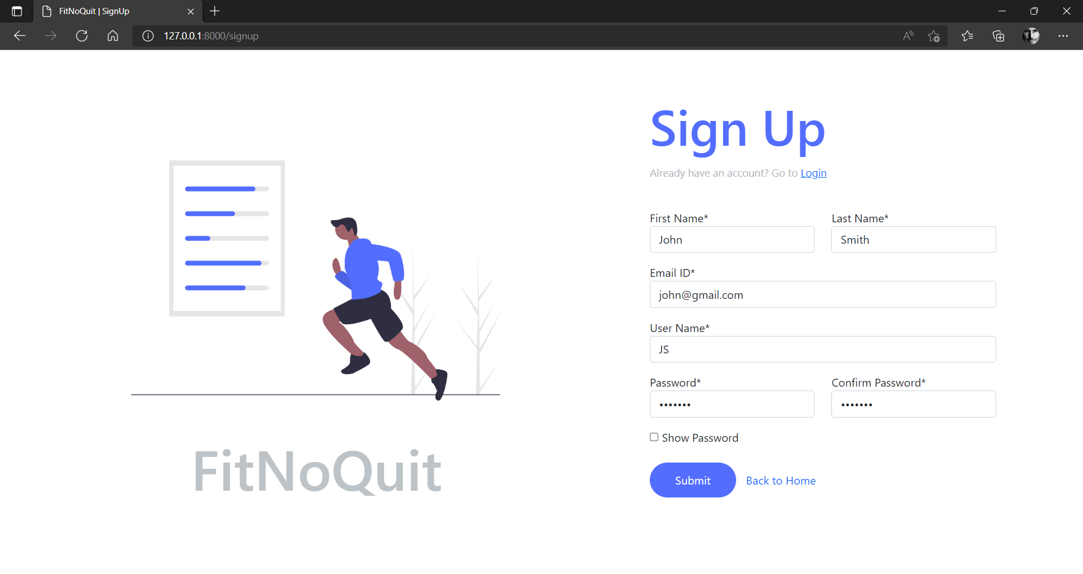

* 1. After successful registration, you can use your credentials to log in to the application and access all the features our application has to offer.

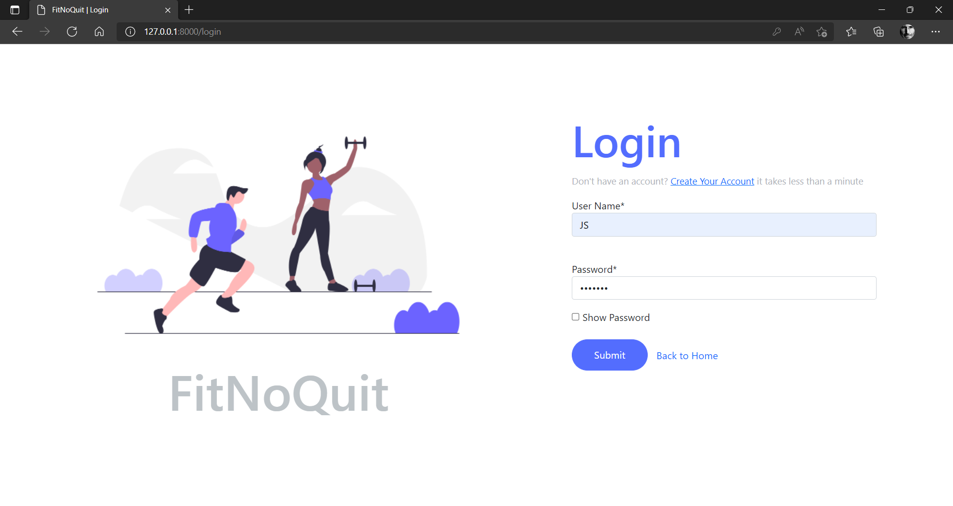

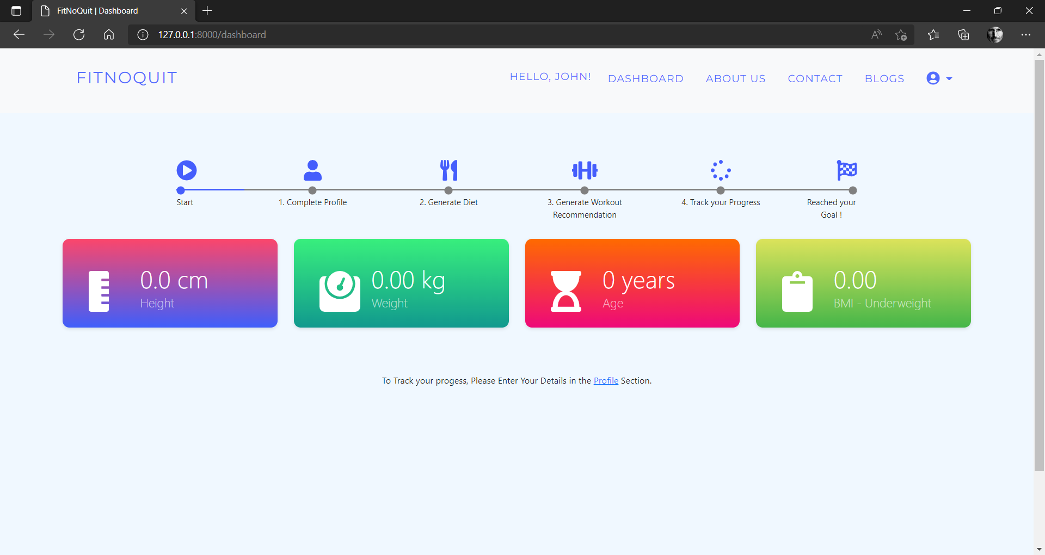

* + - Dashboard after you log in to the application for the first time

1. We understand that every human-being is different and so are the needs and preferences of them. Therefore, to serve you the best, FNQ requires you to enter your details like height, weight, age etc in the profile section of the application. These inputs will help us make calculations and diet suggestions that are specific to your body type and health conditions (if any).

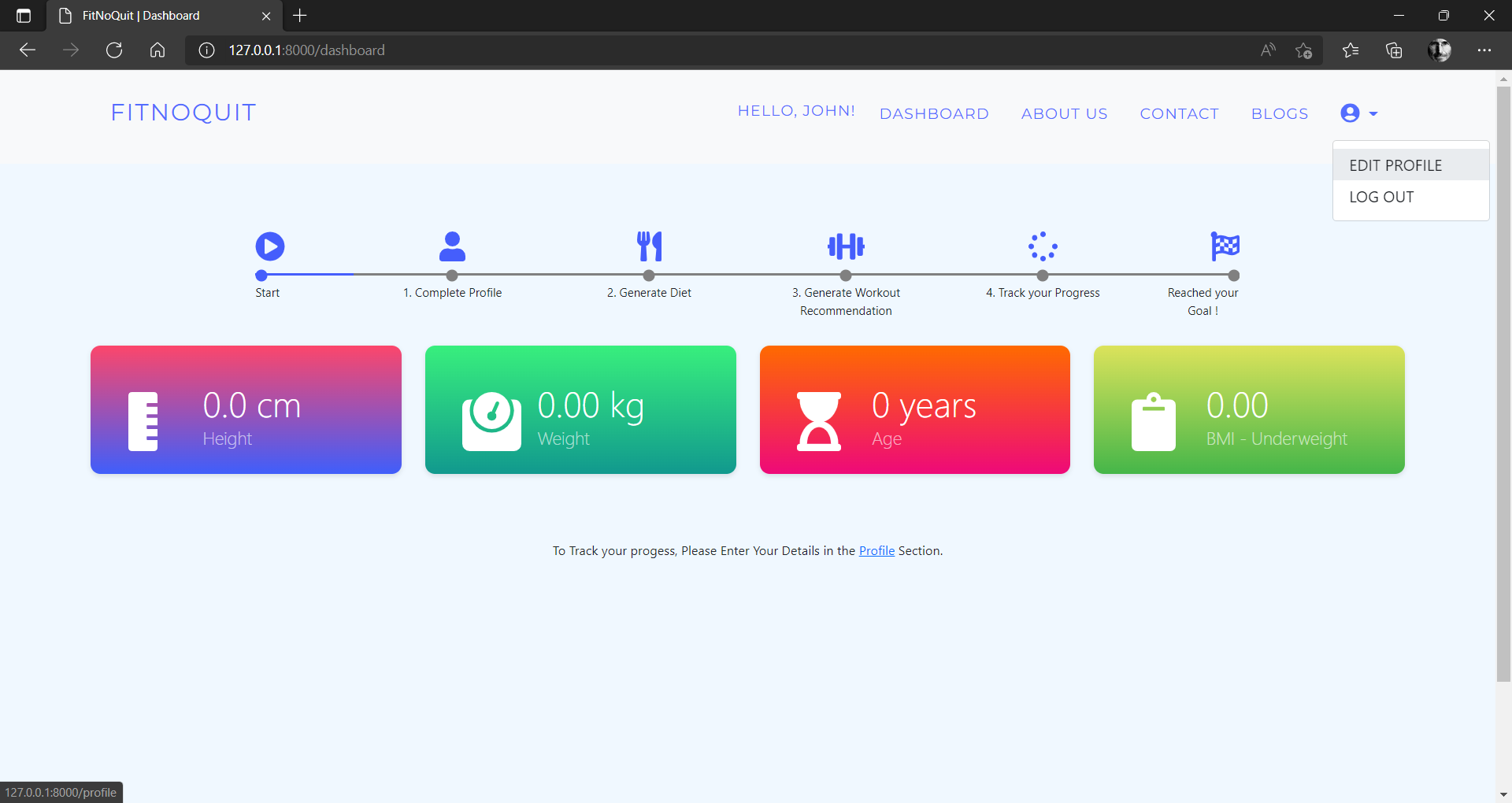

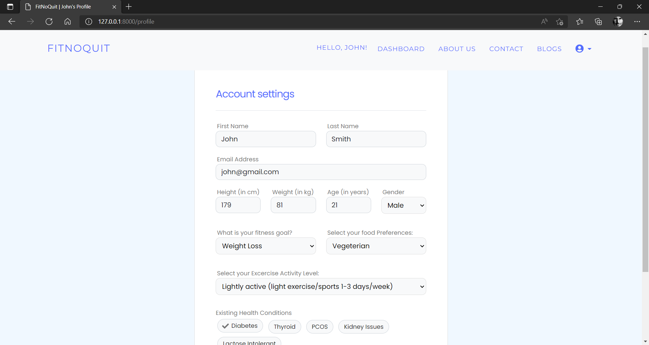

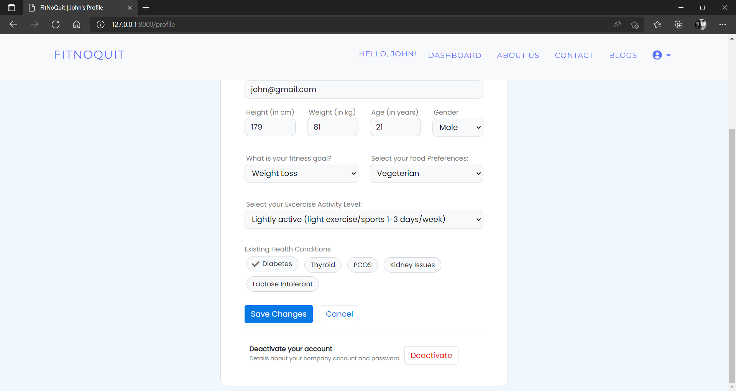

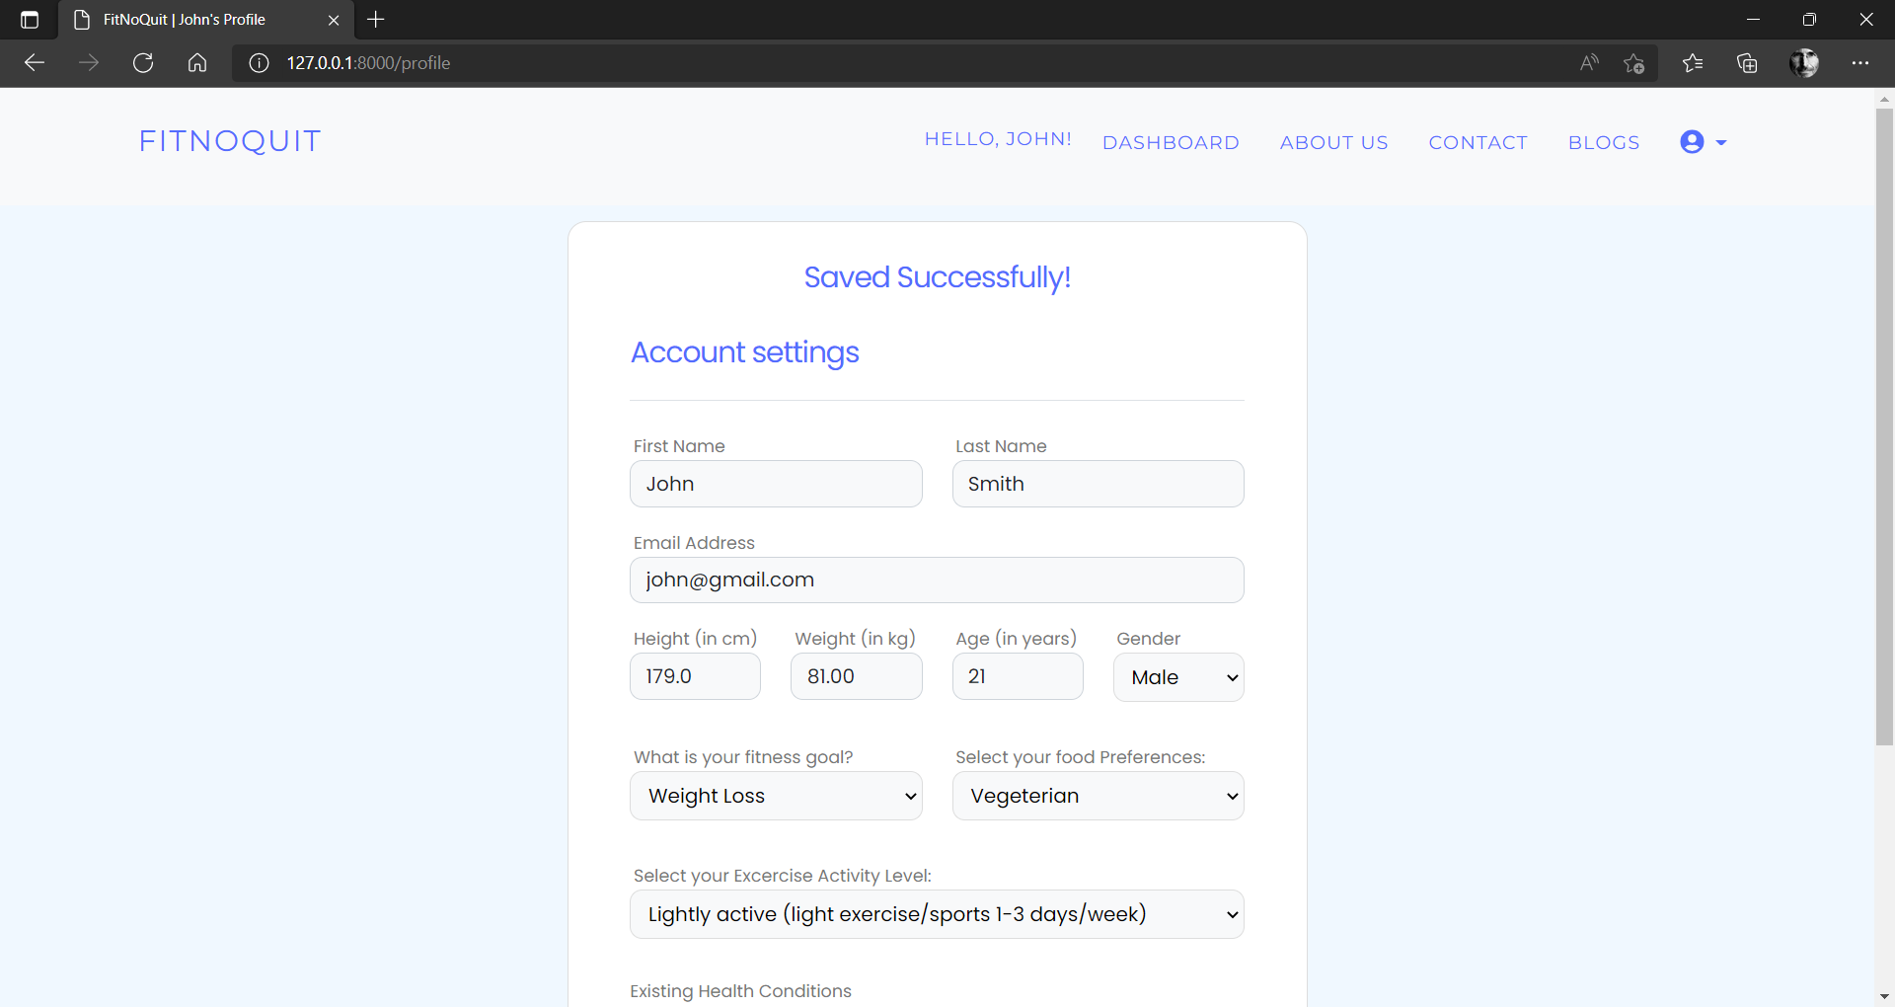

* + - On saving your information, the dashboard will provide a summary of your information as shown below.

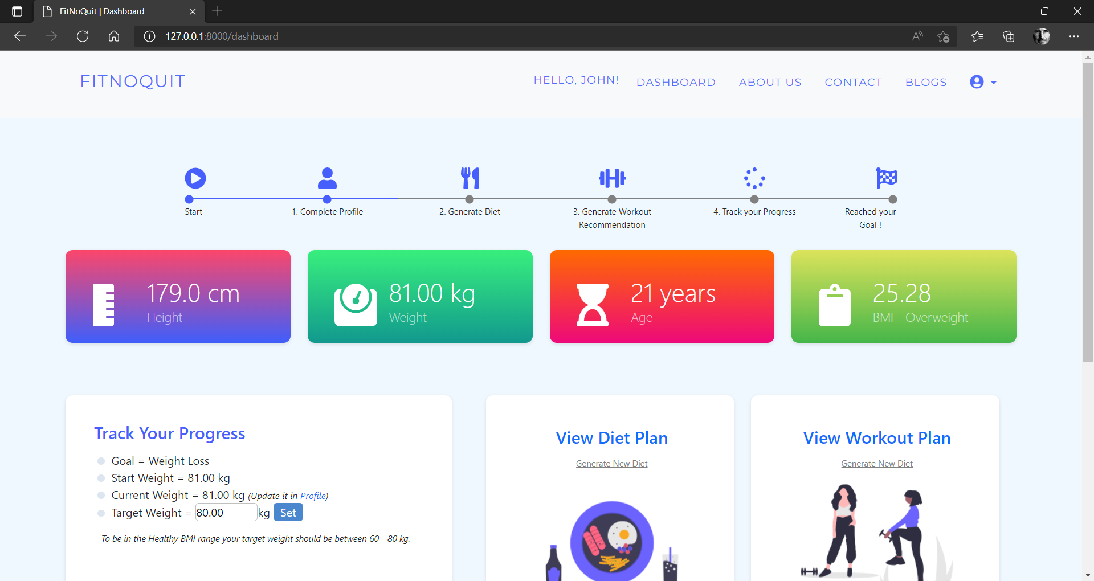

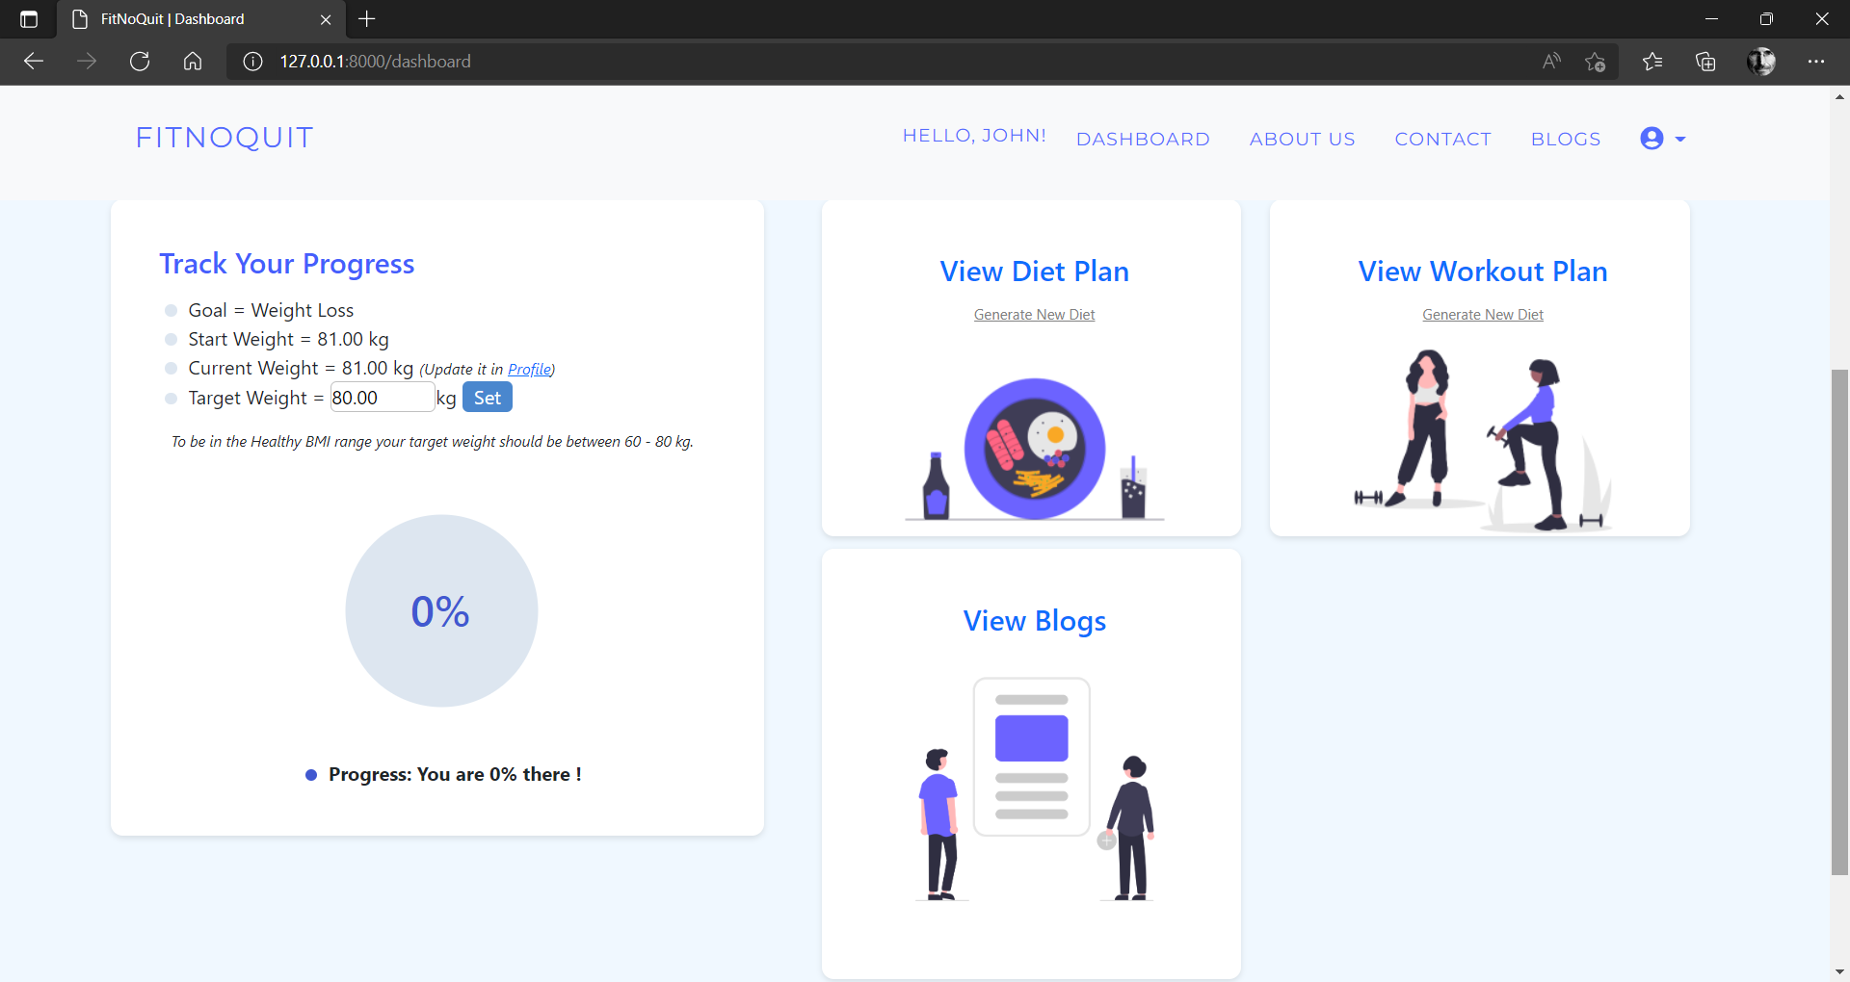

1. Abiding by the famous saying, “You are what you eat”, FNQ prioritizes your diet and suggests meals that are optimal to your fitness goal.
   1. To start with a new diet plan, you can simply click on “Generate New Diet” on the dashboard and enter your food preferences as shown below.

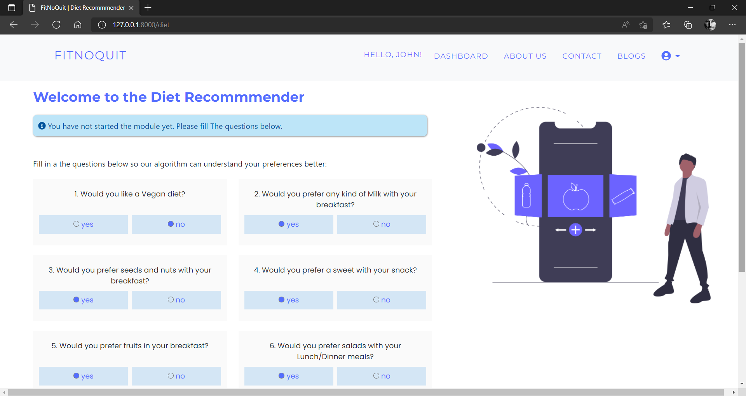

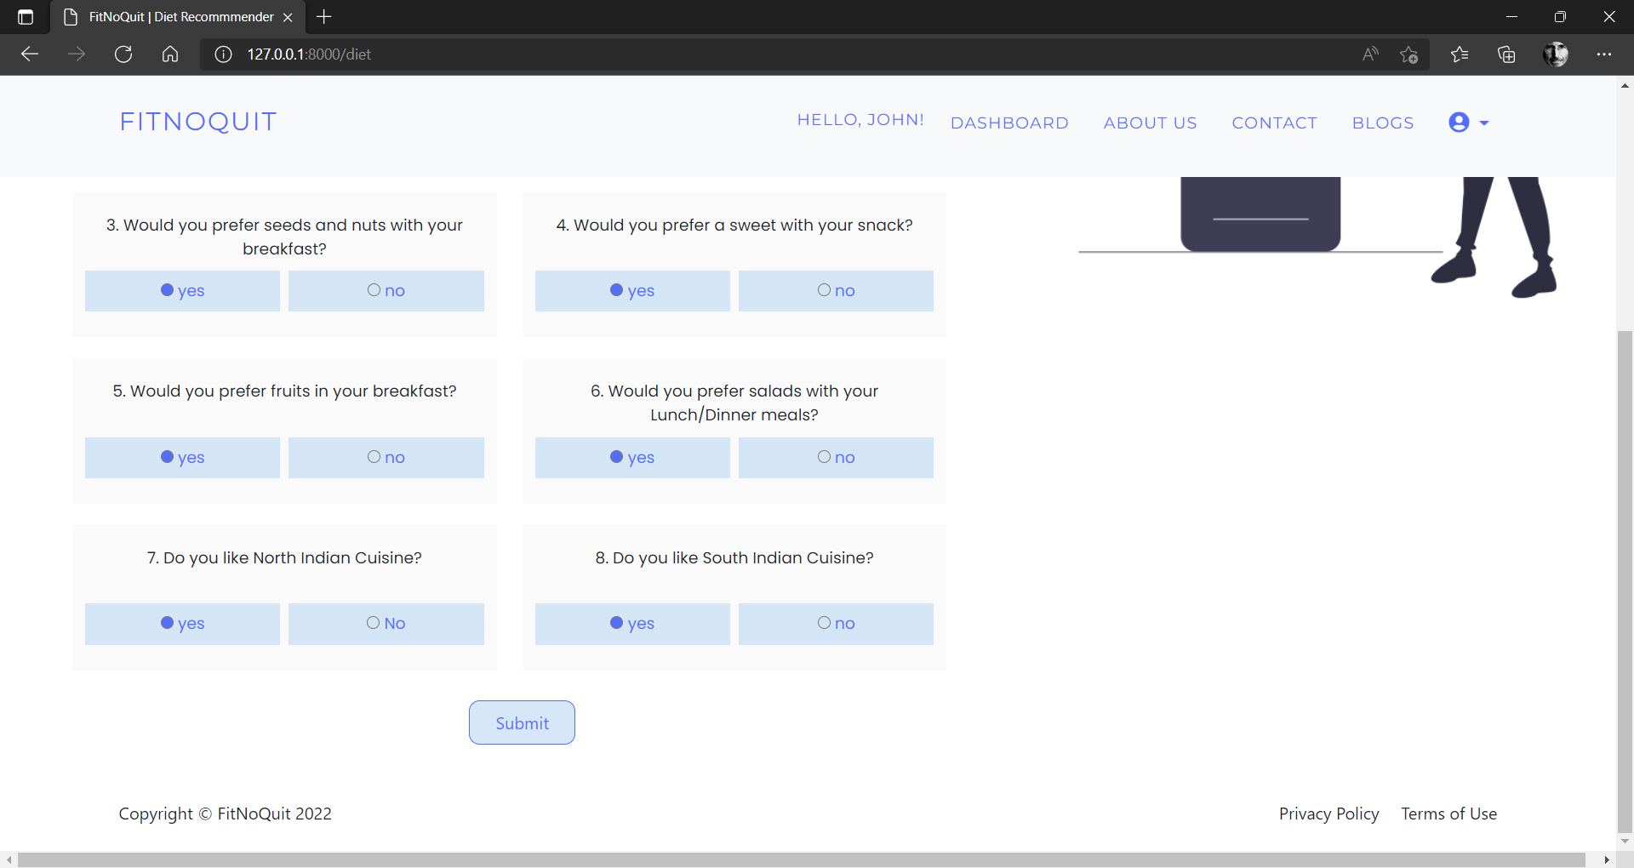

* + - Clicking on submit, the application will run the algorithm on your inputs and generate a diet plan for you as shown below

############ MUSKAAN DIET PIC

* 1. After you have obtained a diet plan, you can always view the diet plan by clicking on the “View Diet Plan” option on the dashboard.

############ MUSKAAN DIET PIC

* + - We understand that having the same meals over time would bore you and hence, we have provided users with the option to regenerate any meal out of the 6 days and obtain variety in food and make the diet plan sustainable.

############ MUSKAAN REGENERATE PIC

1. Even though a healthy diet alone can keep help you stay on track, performing workout everyday is an added bonus and will help accelerate your fitness journey to reach the end goal faster. FNQ gives you the luxury to choose the type of workout you would like to perform and also the duration for which you want to work out on a daily basis. Based on these preferences, the application suggests you with workouts that burn the required number of calories (which is calculated by our algorithm when you set up your profile).
   1. To start with a new workout plan, you can click on the “Generate New Workout” option on the dashboard and enter your preferences as shown below.

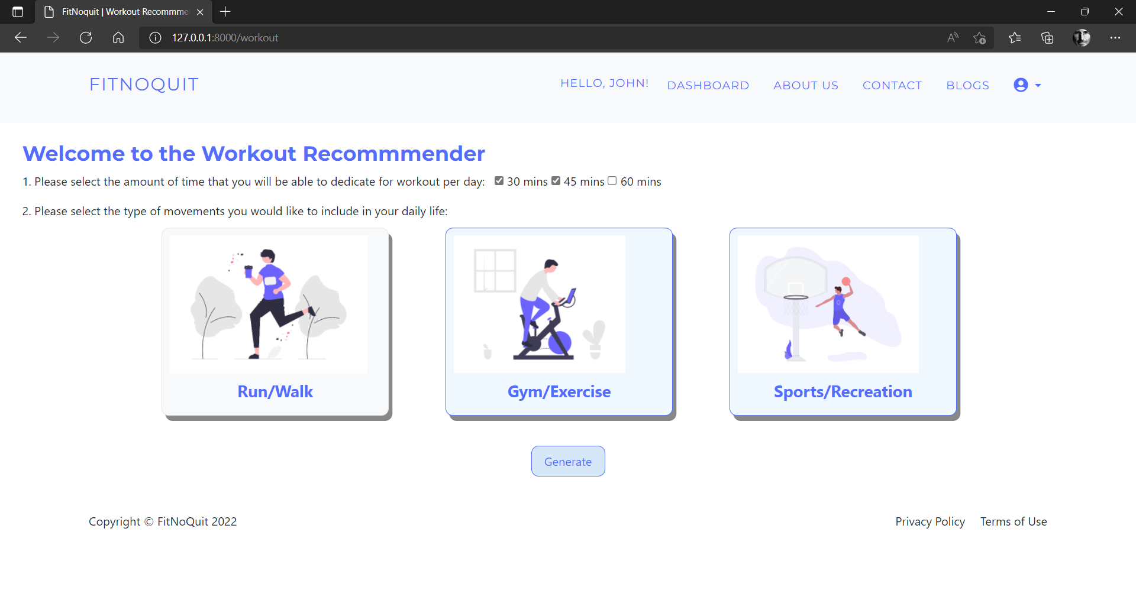

* + - On clicking “Generate”, the algorithm suggests workout that you like and need to perform in order to burn the calories.

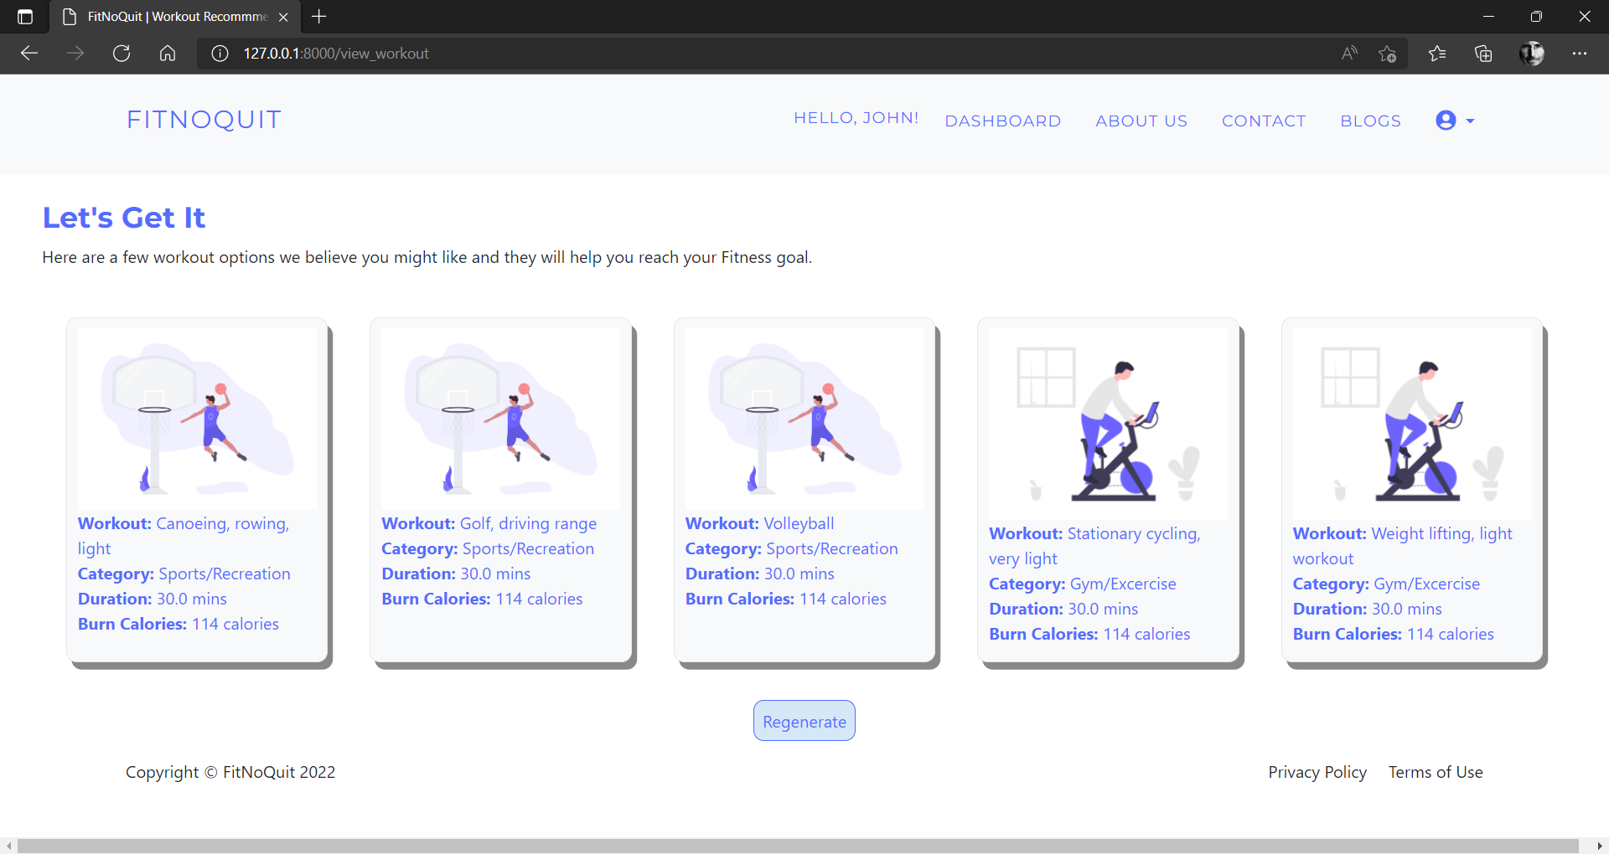

* 1. You can always come back and view the existing workout options by clicking on “View Workout Plan” option given on dashboard.



* + - Further, if you’re not satisfied with the options suggested, you can again regenerate and obtain new sets of workouts.

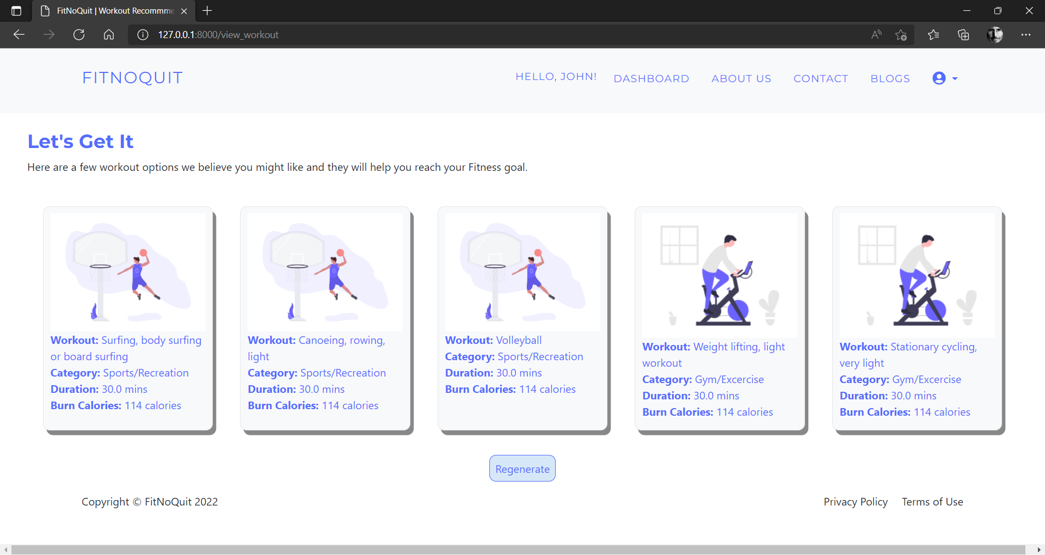

1. After obtaining a diet and workout plan based on your preferences, you have already taken the first step in reaching your end goal. Now all you need to do is track your progress. The interactive dashboard of FitNoQuit will help you track your journey.
   * + You can enter your target weight as shown below and we will let you know how far have you reached in the quest to achieve your goal.
     + Setting 75 kgs as the target weight

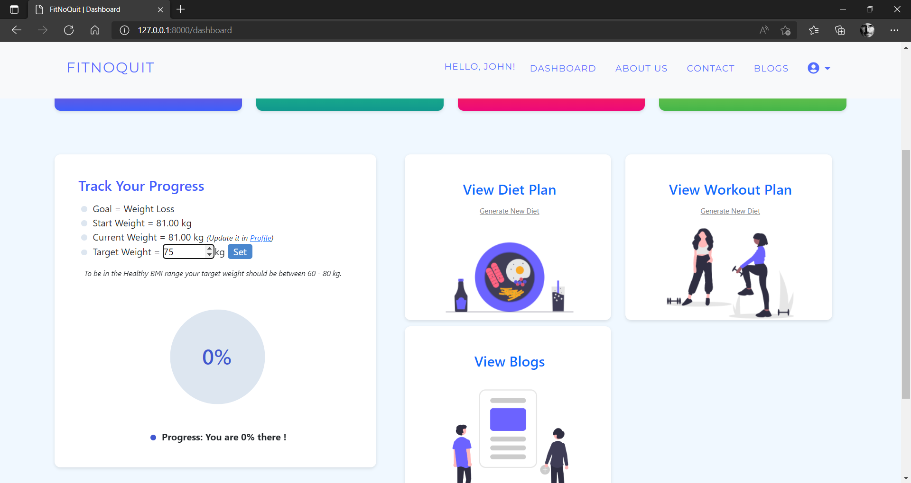

* + - Now you just have to follow the plans suggested to you and keep updating your weight (and any other metric that might have changed) and we will tell you how much have you progressed to keep you motivated in your journey.
    - Updating the user’s weight to 78 and the dashboard will show the progress.

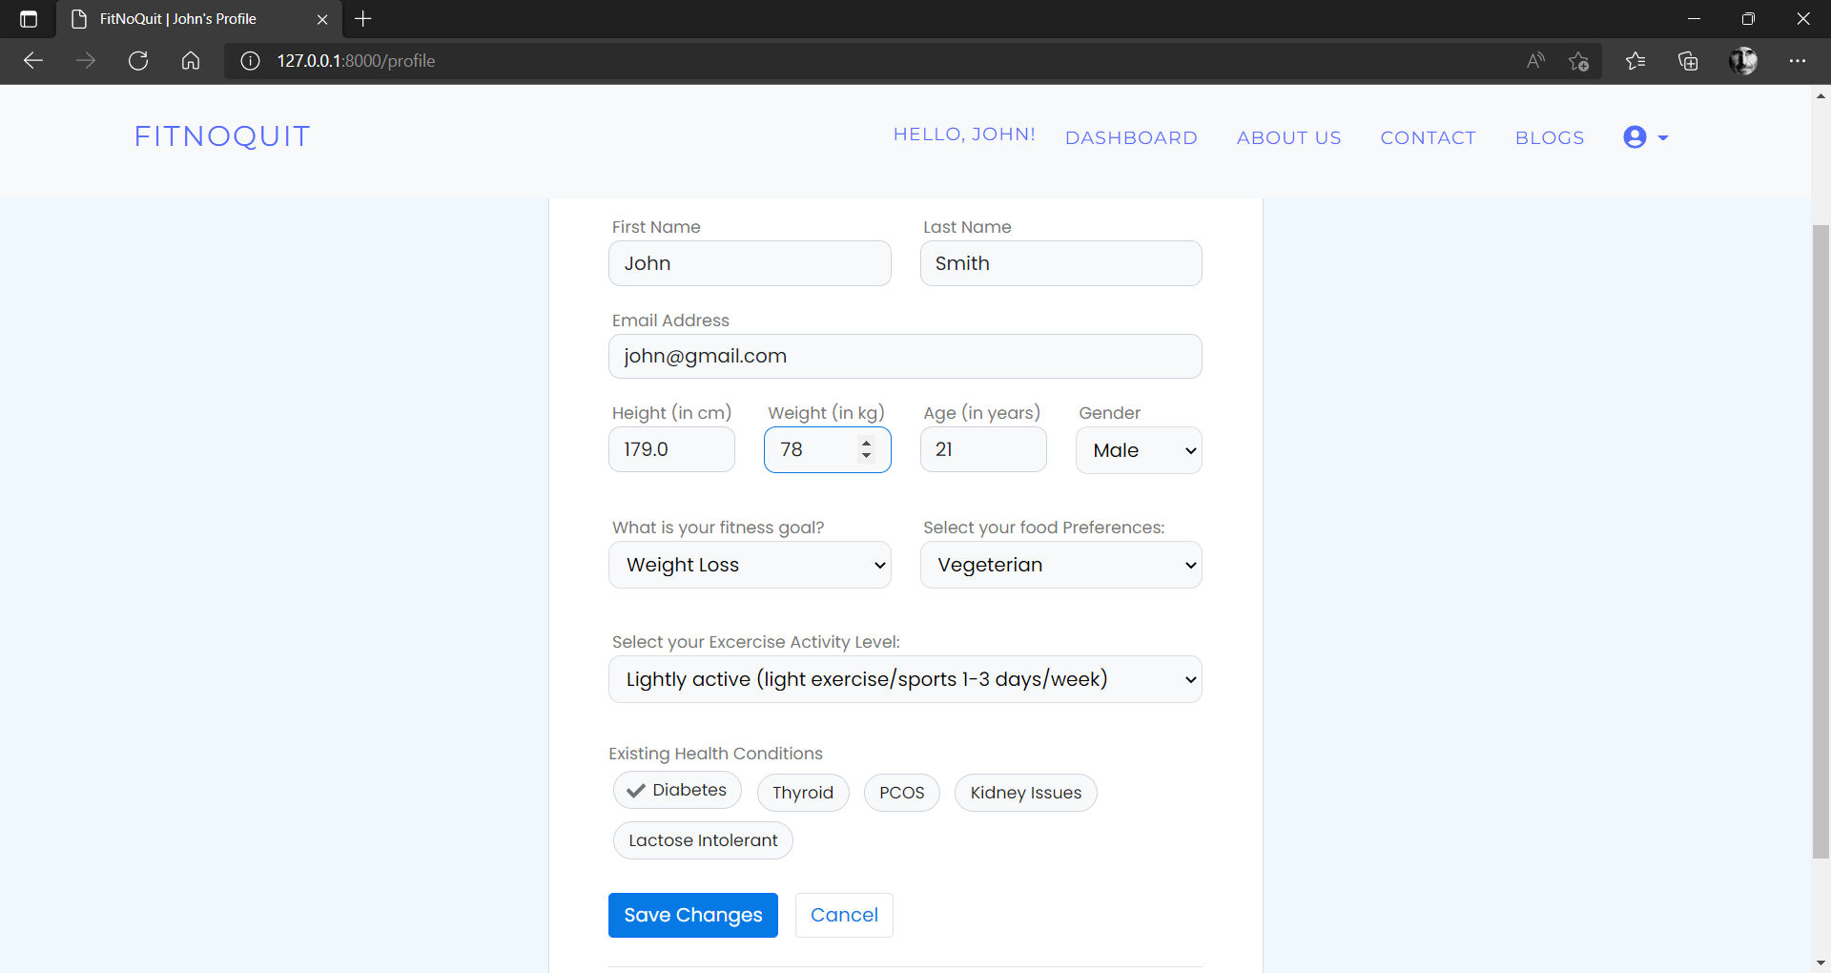

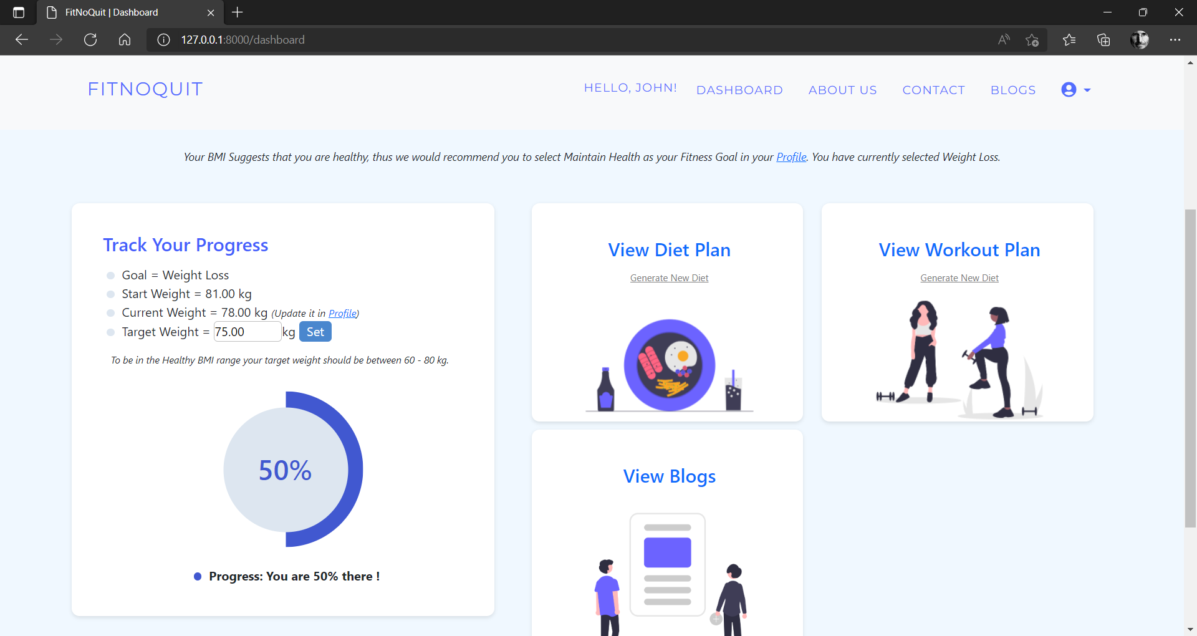

1. Blogs